BESTWOOD VILLAGE WOMENS INSTITUTE

BESTWOOD VILLAGE WI GAZETTE
NOVEMBER 2021 EDITION
FOR THOSE WHO LEAVE NEVER TO RETURN, FOR THOSE WHO RETURN BUT ARE NEVER THE SAME

SAME OLD, SAME OLD MESSAGE
We really hope that you find these newsletters interesting and informative. . As always, if you do have any suggestions on how we can improve the content, have anything you would like to share: poems, recipes, gardening tips, crafts etc. please send them to either Janet or Jan who will do their best to include them.

OCTOBER MEETING
Our speaker, Andy Smart gave us a talk on the history of Nottingham Theatre was o very interesting, although some of us could remember some of the celebrities who graced our stages in days gone by.
Witch’s hats where judged by Andy and first prize went to Marion with Janet a close second. Token prizes were given to all those members who entered the competition and the quality of the entries was outstanding.
The Committee are aware that the room was chilly but the Welfare has been informed and we have been assured that it will be addressed.

NOVEMBER MEETING
24TH November at Welfare Pub + Kitchen 7.00pm
*On this day in 1963 Dallas nightclub owner Jack Ruby short and killed Lee Harvey Oswold.
Also, in 1942 Billy Connolly was born.
This month we will be making and taking Christmas decorations, if you have a glue gun, sticks and scissors could you please bring them with you (mince pies and Christmas tunes will be provided for your delectations).

GUESS WHO HAS A BRITHDAY NEXT MONTH?
This Photo by Unknown Author is licensed under CC BY-NC

Marion Smith – 11th December

CRAFT WORKSHOP
Our craft workshop on the 8th November at the Dynamo Café was a knit and natter morning in preparation for our stall at the Welfare Christmas Fayre

Our next project is to make a Christmas Wreath/Spray/Garland Monday 22nd November, same time same place. If you could bring secateurs, scissors, seasonal foliage and any decorative items (fir cones, ribbons, baubles etc), battery lights can also be used.

2021 PROGRAMME
The programme has now been set and some of our demonstrators and guests have been booked. A full printed programme will be available in the new year.

Don’t forget ladies we still need more members. If you have any friends or family that would like to join us they will be made extremely welcome. The first visit is FREE.

REMEMBRANCE SUNDAY
If you would like to join us in laying a wreath on Sunday 14th November please meet us at AJ’s (the village shop) Park Road at 10.30am
BESTWOOD VILLAGE WI ON TOUR
A mini bus has been hired to take us to Bakewell Christmas Market on 20th November leaving the Community Centre at 9.30am. We still have a few places left and if you would like to join us, at a cost of £16 (this trip is open to guests), please let one of the Committee know.
CRAFT WORKSHOP
Don’t forget your greenery
WI MEETING
If possible, could you please donate a raffle prize as all proceeds will be going towards the Christmas Party. Also, don’t forget your equipment for the decorations and bring along your Christmas spirit (not the sort that comes in a bottle – but then again).
CHRISTMAS FAYRE
The Christmas Fayre will be held on the 5th December at the Welfare Pub + Kitchen starting at 12 noon. If you have any handmade items that we could sell please bring them to the meeting on the 24th November. Also, if you could help us set up between 10am and 12 noon or assist at the sale at any time to suit you please let Elizabeth or Janet know at the WI meeting.

Mulled Wine
750ml bottle of red wine
2 star anise
4 cloves
2 strips of lemon or orange zest, pared using a vegetable peeler
4 tbsp caster sugar
Method (Ensure pan is absolutely grease free or wine will be cloudy and DO NOT use aluminium pan or wine will become black (yuk)
- Put the red wine, cinnamon, star anise, cloves zest and sugar in a large pan. Cook on a low heat for 10 minutes.
- Remove from heat and cool, leaving to infuse for about 30 minutes
- To serve, heat without boiling and pour into mugs or heatproof glasses.

Alternatively buy at supermarket
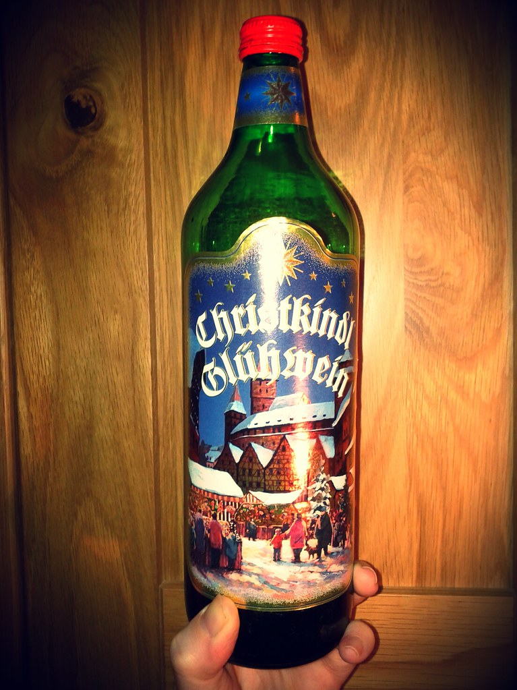

IMPORTANT
PLEASE MAKE A NOTE THAT OUR CHRISTMAS PARTY WIL BE ON WEDNESDAY 15TH DECEMBER AT 7PM.
PLEASE ADVISE OF ANY FOOD ALEGERIES
Please remember to let Jan know if there are any changes in your contact details

Please feel free to share this newsletter with family and friends to encourage them to join us.

CONTACT DETAILS
Elizabeth Heard, President Tel: 0115 9750787
Janet Wheat, Vice President Tel: 07758 862990
Jan Pauley, Treasurer & Secretary Tel: 07944 214028

